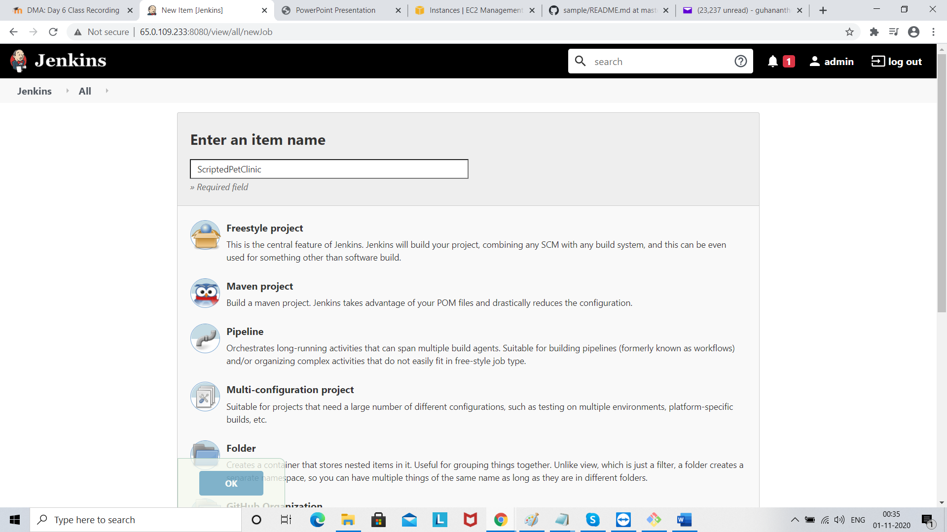

Select pipeline and click ok

Then go to pipeline and paste code from Code is available in DevOpsMasterJenkins/ScriptedPetClinic/pipeline.txt

